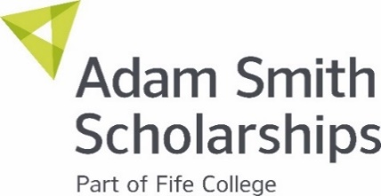


Batchelor Trust Scholarship Guidelines

What is the Batchelor Trust Scholarship?

This scholarship aims to give financial support to help individuals come to Fife College and secure a ‘trade’ in the areas of construction, electrical, gas, engineering and fabrication and welding. The Batchelor Trust was set up in 2019 to increase access to further education across the East of Scotland.

Who Can Apply?
- School leavers who left school in 2025, and are enrolled on a Fife College course.
- Mature students who are keen to secure a new ‘trade’
- Full-time students at Fife College who wish to progress on to the next level, have good levels of attendance and are keen to use their qualifications to enhance their career prospects.

Individuals should be studying one of the following courses:
- Construction Futures SCQF Level 4
- National Progression Awards Carpentry & Joinery
- National Progression Awards Painting & Decorating
- National Progression Awards Trowel Trades
- National Progression Awards Plumbing & Electrical Building Services SCQF Level 5
- Certificate: Gateway to Engineering (Including Automotive)
- Certificate: Gateway to Engineering (Including Electrical)
- NC Electrical Engineering
- NC Engineering Practice SCQF Level 5
- NC Fabrication and Welding
- NC Mechanical

What Will You Be Awarded?
Awards of between £500 and £2,000 will be available per student at the discretion of the panel. Awards may be given in two payments, (approximately November and March) subject to good attendance and achievement.

What Can You Spend the Scholarship On?
The scholarship should be used for resources or materials that would help you with your studies or take that next step in to future studies or employment. It can also be spent on general living costs and bills that you may be struggling with.

How to Apply
A link to the application form is available HERE. Please remember to explain clearly why you should be considered for this scholarship.
What Happens Next?
We may ask a staff member who knows you for a reference, we will advise the outcome of your application by email.

Key Dates
Closing date for applications is Wednesday 10 December 2025.

Got a question?
If so, just drop us an email, scholarships@fife.ac.uk

Previous Winners
Check out the winners from last year below:
