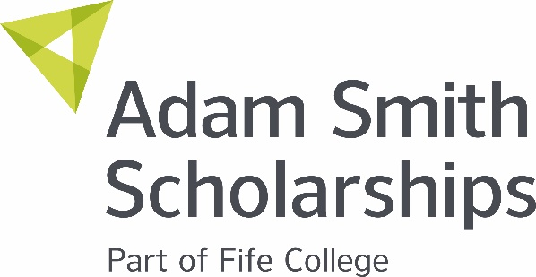

New Park Educational Trust Care Experienced Scholarship

At Fife College we are committed to supporting our students who are care experienced. This scholarship gives students some extra financial support while they study to help them become more independent, give them a boost and make life a little easier.

We are delighted to receive funding for this scholarship from the New Park Educational Trust, a Fife charity which supports the education and development of young people.

Who Can Apply?

Full-time students at Fife College who are care experienced.
This means anyone who has experience of being in care at any time of their lives, or who is currently in care or looked after.
This includes any students who are under the care of the Local Authority, including (but not limited to) where the care is being provided in the student’s own home, in their parent(s) home, in the home of relatives, in a foster home, a care home, or a residential unit. It also includes students who are cared for under a kinship order.

What Do You Gain?

A generous share of £2,000 is available to support students. You may be awarded a sum of money between £50 to £500. Being recognised for this award is also a fantastic achievement and would look great on your CV boosting your further study and employment prospects.

What Can You Spend the Scholarship On?

This scholarship is to support you while you study to help with items you need for your course such as a new laptop, equipment or travel expenses. It can also be used to help with any costs to allow you to live independently.

How to Apply

A link to the application form is available on the Fife College website in the Scholarship section – if you require a hard copy form please get in touch. Please remember to explain clearly why you should be considered for a New Park Educational Trust Scholarship giving as much detail as you can on the application form.

What Happens Next?

References: We may ask a staff member who knows you for a reference.
Certificate: If you are successful, we will email you to let you know and attach your certificate and a form to complete your bank details so we can make your payment.

Key Dates

Closing date for applications is Wednesday, 14 January 2026 at midnight. Awards will be made after the Christmas holidays.

Got a question?

If so, just drop us an email, scholarships@fife.ac.uk

Previous Winners:

