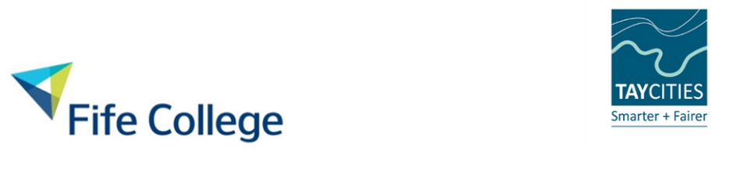
Expression of Interest for Grant Funding
Hospitality Skills Training & Leadership Skills
Frequently Asked Questions (FAQ) – this is a live document and will update as and when questions arise.
Questions | Answers
How long will the project last? | Project delivery is for 4 years until 2030
How has the project been funded? | Funded by the Scottish Government within the Tay City Region Deal
What businesses can apply for training? | Restaurants  Cafes  Pubs  Bars  Visitor attractions (with catering)  Hotels  Campsites  Other accommodation
Can it be any size of business that apply? | Yes, nothing is too large or small
What will you do with my data? | Your data matters, so we will keep it safe and you can unsubscribe at any time https://tinyurl.com/Fife-College-Privacy-Notice
Where does the QR code take me? | The QR code will take you to The Hospitality Skills Project microsite that it situated within the main Fife College website
What will happen after I complete an Expression of Interest (EOI) MS Form? | The information you provide will help us carry out a needs analysis which forms an important part of your future grant application, therefore, completing the EOI will get you ahead of the process. we will connect with you to explore your application against the training opportunities.
What will happen if you don’t know what training you or your business needs? | A member of the team will be in touch to talk you through your personal business needs and identify what skills and training is available to you and your business (should this be needed).
Is there a time limit that I need to apply? | The application is open all year.
How much training can we apply for? | This will depend on your business needs and the funding cap per business.
How long do have to use the funding? | Training must be organised within the quarter that the award is made, exceptions will only be made for specific circumstances.
Are there any conditions? | Terms and Conditions will be shared and signed  - There will be limited number of changes once the training has been organised.  - Not attending the training sessions will result in costs to the business.  - Feedback to the team regarding the training.  - Feedback to the team regarding the difference the training has made (post 6 months after).
Do I need previous hospitality experience to be on a course? | No, the Hospitality Skills Project is open to anyone working within the hospitality industry in the Tay City Region.
Will the training be online or in person? | This will depend on the training your business is participating in, but it will be predominantly in person.
Will the training cost me any money? | No – the full cost of the training will be covered by the Hospitality Skills Project. The only costs you may need to cover are any personal expenses required to attend the training, for example travel.
Do we get any travel expenses? | There will be no award to your business or employees of travel expenses.
Can we buy equipment? | No, the project is for training purposes only.

